BELMONT CENTER OVERLAY ZONING
FREQUENTLY ASKED QUESTIONS
V7.1 December 2025

TABLE OF CONTENTS
- GENERAL QUESTIONS
  - What is being proposed for Belmont Center? What is this project?
  - What is the area being proposed for these zoning districts?
  - Why is this being done?
  - Why was Belmont Center chosen for this now when there are other areas that could have been selected for new zoning first?
  - How will the proposed zoning overlays be different from the underlying zoning?
  - What is Belmont trying to accomplish with these zoning overlays?
  - Why is this project important for Belmont?
  - How and when do you anticipate development to occur once zoning is in place?
  - How much could be built in Belmont if these By-Laws are passed?
  - How can I get more information about this project?
  - What will the impacts of this zoning be, both positive and negative?
- EXPECTED POSITIVE IMPACTS
- OTHER POSSIBLE IMPACTS
- Parking & Traffic Impacts - What about cars emanating from the proposed zoning, impacting traffic and parking?
- Fiscal Impacts - Is this another situation where we need to be concerned about impacts to the Town budget due to an influx of school children?
- Small Business Impacts - What will be the impact on our small businesses? Will traffic create barriers to their customers? Will construction interrupt their business? Will new businesses outcompete them? Will a shortage of parking be a problem? Will rents rise and force them out?
- Infrastructure Impacts - How will our utility systems like water, sewer, and electricity be able to handle the scale of new development that is being proposed?
- HISTORIC PRESERVATION
- How will this new By-Law impact historic properties in the Center?
- DIMENSIONAL REQUIREMENTS & OTHER ZONING OVERLAY SPECIFICS
- This Form-Based Code zoning is very lengthy and highly complex. It seems too technical to be appropriate for Belmont and too much for Town Meeting Members to adequately absorb.
- What are the maximum building heights proposed for this district?
- We heard that there will be eight story buildings in the center. Is this true?
- FEEDBACK & CLARIFICATIONS
- What is the voting threshold for this zoning overlay amendment? Is it 2/3 or a simple majority?
- What if the article fails at Town Meeting? What then?
- This seems to be proceeding too quickly compared to other similar bylaw changes in town. Why is this?
- We haven’t seen any notices or any other information about this project. We are just learning about it. Why hasn’t the Town done more to reach out to Town Meeting Members and other citizens?
- Why have many meetings avoided public Q&A or limited it to specific narrow topics? Also, why have some important meetings not been open to the general public?
- It appears as though the Select Board and Planning Board are predisposed advocates for this project and are trying to force this on the town. It also seems like much of this is being conducted covertly and without public scrutiny.
- I have heard some suggest that project advocates are “pie in the sky”, utopian, or supremely optimistic about this zoning assuming that whatever is proposed will be built.
- We have heard about negative environmental impacts resulting from this zoning? Is this true?
- This is a very long and complex By-Law and adds nearly 100 pages to our existing Zoning By-Laws. How can you justify this?
- We heard that as many as 700 new apartments could be built in the Center due to this rezoning. Is this true and how can you justify that given what I understand are negative fiscal impacts from new housing?
- How were the Buildout estimates developed that informed the Fiscal model?
- Appendix A – Town Center Demographics
- Appendix B – Form Based Codes Primer

GENERAL QUESTIONS

Q1: What is being proposed for Belmont Center? What is this project?

A1: The Town of Belmont is considering a new strategic Zoning By-Law overlay for Belmont Center (Belmont Center Overlay District or BCOD and the Center Gateway Overlay District or CGOD) to encourage more commercial development and complementary residential development, otherwise known as “mixed-use” development. The proposed zoning consists of five (5) subdistricts, each having different building types, heights, and land uses which are intended to reflect the intended level of change sought for each area. The underlying LB1, SR-C, and GR zoning for the parcels in the project area will remain in place.
Figure 1 - Belmont Center Overlay District (BCOD)  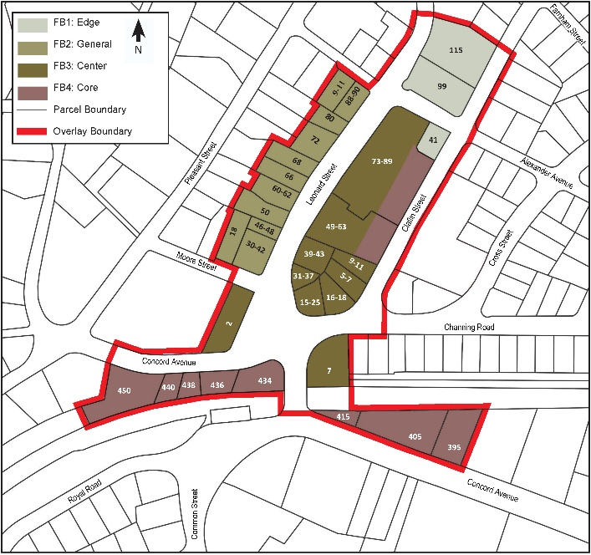 | Figure 2 - Center Gateway Overlay District (CGOD)  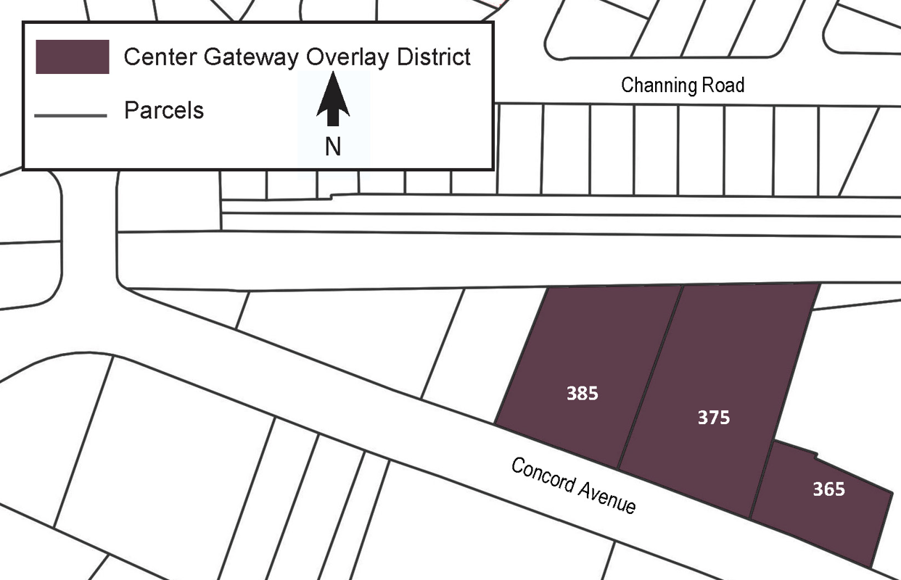

The BCOD currently consists of four zoning subdistricts, FB1 through FB4. It previously included a FB5, but this has been removed and this area is now proposed to be a new Center Gateway Overlay District (CGOD) which is intended to encourage hotel development and is located on Concord Avenue. See maps of the two districts above.

The BCOD is proposed to be a new Section 10 in Belmont’s Zoning By-Laws and the CGOD is proposed to be a new Section 10A. We are also proposing a new Section 6.15 to provide language to regulate hotels. To complete this zoning effort, we intend to bring additional sections to the Annual Town Meeting in 2026 to strengthen Design and Site Plan Review and to provide sections on construction management and transportation demand management.

These proposed changes to zoning impact what is allowable to be built; they are NOT a specific development project or proposal that is imminent. This isNOT an agreement with a developer or building contractor and there is NOT a requirement for any property owner to develop their property.

Q2: What is the area being proposed for these zoning districts?

A2: Please see the project area maps above for the exact extents. The BCOD area consists of Belmont Center including Leonard Street, Claflin Street, Cross Street, and Alexander Avenue in the commercial area, plus Concord Avenue and Channing Road near the Center. The CGOD area consists of three parcels on Concord Avenue.

Q3: Why is this being done?

A3: This step is being taken now for several key reasons:

- To revitalize Belmont Center
- To improve the Town’s finances
- To create options and opportunities for all Belmontonians
- To create more (and a greater variety of) housing and amenities
- Improves the environmental footprint of Belmont

More specifically:

- It responds to a specific plan that was drafted for the center in 2008. One of its key recommendations included zoning that was specific to Belmont Center.

- The Center needs an infusion of vitality and design enrichment to enhance its status, visibility, and functionality. There are empty storefronts and significant turnover of tenants on Leonard Street that have been an ongoing challenge.

- Due to a long-standing structural deficit from an over reliance on Belmont’s residential tax base, it can serve as a great opportunity to facilitate new economic development activity in Belmont. This is just one step of many the town is considering to incentivize increased commercial development, grow the commercial tax base and support local services.

- It permits the community to better compete economically with surrounding communities while still maintaining the unique characteristics and historic development patterns of the area. There is significant leakage of Belmont consumer dollars being spent in other communities which have commercial offerings that Belmont does not. This lost opportunity to circulate Belmont resident spending in Belmont is a key issue to overcome.

- This type of zoning, once adopted and implemented, will be more straightforward and clearer for developers and property owners to work with. It also simplifies and reduces the administrative workload on Town staff. This change will help the perception that Belmont is becoming more business-friendly.

- Provide a wider range of shopping, services, and amenities for Belmont residents and visitors.

- Provide a greater variety of housing options our residents including seniors, empty nesters, new graduates, and others.

- Improve the environmental footprint of buildings and sites in the Center.

Q4: Why was Belmont Center chosen for this now when there are other areas that could have been selected for new zoning first?

A4: Belmont Center has been extensively studied in the recent past including a vision plan (A Planning Vision for Belmont Center) developed in 2008 and the draft 2010 Comprehensive Plan that outlined a number of goals and actions for the Center.

Given that the Center has already had effective and relevant background planning conducted, which is not the case for a number of other areas considered for development, it made sense to start here. Also, Belmont Center, as defined by the project area, is smaller than other considered areas. It already has a traditional town center pattern of development and is the commercial and cultural hub of the community, so the effort was deemed a good fit for a first project.

The initial expectation was to do both zoning for the Center and another area of town. Concern from residents over multiple zoning changes at once has slowed that progress, making it difficult to incorporate other areas into this project. However, the Town has initiated a similar project in the Brighton Street area, starting in the fall of 2025 with a similar Vision Plan process.

Q5: How will the proposed zoning overlays be different from the underlying zoning?

A5: The proposed new zoning is a Form-Based Code, meaning that it regulates the building form to ensure any new development is complementary to the existing development pattern and provides new forms desirable to the community. The proposed zoning allows more height and density, creating opportunities for new commercial and residential development—if property owners choose to pursue them. These changes are meant to strengthen the Center as a destination, not to mandate any specific project or immediate redevelopment.

It regulates the way buildings look and feel and engages with the overall built environment and people rather than only considering land uses, height, and setbacks. Once in place, the zoning should more efficiently proceed through the review process while resulting in better projects for Belmont.

For more information on form-based codes from the Form-Based Codes Institute, see HERE.

Q6: What is Belmont trying to accomplish with these zoning overlays?

A6: The overall goal is to offer zoning options that improve design quality of any new development or redevelopment, add new commercial space and new residential uses to increase foot traffic for businesses, and improve the overall feel and vibrancy of Belmont’s iconic town center. More specifically, there are several objectives:

- Develop zoning that encourages a sensitive and complementary development of commercial, mixed-use, and hospitality uses in buildings that are incrementally denser than the current pattern of development but still appropriate for the scale and context of Belmont Center.

- Pave the way for an opportunity to provide amenities in the Center such as an improved pedestrian environment, attractive architecture to complement Belmont’s traditional design theme and historic development patterns, multi-generational spaces for shopping and activities, new uses and product segments not currently available in the Center and throughout Belmont, and new housing types not currently being served such as seniors, empty-nesters, young professionals, workforce housing, and others.

- Addresses the critical need to take advantage of potential development areas to reduce the structural budget deficit of the Town by expanding the commercial tax base and reducing the tax burden on residential properties in supporting town services and facilities.

Q7: Why is this project important for Belmont?

A7: This project is important for several very specific reasons:

- Substandard Zoning By-Laws

- Right now, Belmont’s Zoning By-Laws are archaic, substandard, and do not encourage or facilitate the types and quality of development and types of uses that Belmont needs to have a prosperous future. This By-Law is the first fundamental example of a Form-Based Code to be used in Belmont which is a model that will much more likely result in the types of building forms that are desirable.

- Our current By-Laws often lead to undesirable outcomes and do not allow for the range of uses and building types that are desired by the community. It is also prohibitive of efficient and timely outcomes.

- This amendment to the Zoning By-Laws will be a positive first step in providing the type of zoning that will enable the kind of development that will enhance our commercial centers and create a predictable path for developers while protecting the interests of Belmont with a robust but reasonable review process.

- Belmont Center Needs Revitalization – While a very cherished and valued place, the Center is in need of additional scale and investment to take advantage of market opportunities, add needed residences to increase vibrancy and buying power, and enhance aesthetics in existing and new buildings. It addresses the need for long-term economic viability and addresses the dynamic needs of the community. Other than public way improvements, the Center hasn’t experienced any significant private sector investment in years.

- Economic Development – Belmont Center is one of several commercial areas in Belmont that, if upzoned, has the capacity to allow for more commercial development, add to the tax base, and increase overall economic activity in the Town.

Q8: How and when do you anticipate development to occur once zoning is in place?

A8: The short answer is that we cannot know for certain. While zoning is a tool the town can use to dictate development patterns and incentivize certain types of building forms and development projects, it is ultimately up to the private market.

New zoning is unlikely to spur a burst of development activity and any new development is more likely to occur over a longer period of time—likely many decades or more. Some property owners may be satisfied with the status quo and choose not to redevelop or find that development feasibility does not currently work for them. Others may see added value in utilizing the overlay and choose to redevelop their property accordingly.

The Office of Planning and Building convened a developers focus group in the spring of 2025 and learned that some larger parcels may be more attractive for redevelopment and the smaller parcels less so. Since the Center is largely made up of smaller parcels, it may be some time before those are considered, particularly while the economy may not be very favorable for development. The pace of development is impacted by macro-level variables such as interest rates, economic indicators such as the price of construction materials, and the overall health of the economy (market sentiment and consumer confidence). We believe that if the market indicators are weak, very little redevelopment, if any, will occur in the Center. As the economy picks up or other limiting factors change, we are creating more opportunities for new development projects to occur based on the needs and objectives of each property owner and the marketplace.

Real estate development is also impacted by government policies and regulations such as the new energy stretch code and inclusionary housing requirements, tax rates, local zoning and building regulations, and permitting processes and capacity. The Town has influence on some of these factors and needs to be sensitive and responsive to how they can impact potential development.

Q9: How much could be built in Belmont if these By-Laws are passed?

A9: First, it must be emphasized that nothing is mandated or required to be built, nor does it mean that the maximum allowable will be built based on the new zoning. With that in mind, the Form-Based Code model currently estimates that the following new commercial, residential, and hospitality space could approximately be developed with ranges between the minimum base zoning and the maximum using density bonuses for public benefit incentives, using full buildout scenarios:

- COMMERCIAL: Approximately 393,000 net new square feet, minus the existing development. The proposed zoning requires all development to have a minimum of two full floors of commercial space, except for the hospitality uses in CGOD parcels on Concord Avenue.

- RESIDENTIAL: Approximately 391,000 net new square feet. It is assumed that any residential units will be largely studios and one-bedroom units with possibly a few two-bedroom units. We expect anywhere from 180 to 521 residential units based on the square footage and unit size.

- HOSPITALITY: Up to 80,000 net new gross square footage and 67,000 dedicated to guest rooms. This would likely be contained in one building in the proposed CGOD overlay district along Concord Ave and the numbers are derived from an assumption that 5 of the 6 floors would contain hotel rooms averaging 400 sq. ft. per room. Since hotels are limited to 150 rooms by Special Permit, the maximum project size would be likely around 67,000 sq. ft. of guest area and the remaining space for common or non-guest room area and retail space.

Note that at present, the project area contains 275,300 sq. ft. of commercial space and 46,961 sq. ft. of residential space. Thus, any space projections would also be reduced by these numbers.

In summary, these numbers are best estimates based on the buildout analysis and it should be noted that with potential constraints on development, some properties will not be able to be developed or fully developed. Other buildings may be preserved with historic preservation incentives and not developed.

Q10: How can I get more information about this project?

A10: Interested and residents and stakeholders can find project information in the following locations:
- The Belmont Center Zoning Project page, which can be found HERE.

- You can also sign up for news in the News Flash item named “Belmont Center Zoning Project” on this page https://www.belmont-ma.gov/list.aspx#newsFlash.
- You can attend Planning Board meetings or other special meetings sponsored by the Planning Board or other town board and committees, which are listed on the Town Calendar.

- If you have any specific questions, you can send in a comment or question to the Comments Form for this project which is located on the following page https://www.belmont-ma.gov/2039/Belmont-Center-Comments-and-Questions.

Q11: What will the impacts of this zoning be, both positive and negative?

A11: We have broken out impacts below into anticipated positive impacts and possible other impacts. These sections will be updated as new information is received.

EXPECTED POSITIVE IMPACTS
There are three (3) frameworks to evaluate expected positive impacts related to zoning reform:

- Neighborhood Impact – Do the proposed zoning changes improve the neighborhood by making it more vibrant, more attractive, doubling down on its strengths, and mitigating its weaknesses? Planners note a number of concrete measures they use to determine what is a good neighborhood and what is not:

- Good Urban Design – This plays a pivotal role in shaping the character and functionality of a neighborhood. It can address issues of density and land use, ensuring that neighborhoods are both vibrant and efficient.

- Accessible and Safe Public Spaces – By providing a variety of public spaces, neighborhoods can cater to different interests and demographics, promoting inclusivity and connection.

- Mixed-Use Development – Mixed-use development integrates residential, commercial, and recreational facilities within a single neighborhood. This approach reduces the need for long commutes, promotes walking and cycling, and enhances the vibrancy of the community. Residents have easy access to shops, restaurants, and entertainment, creating a lively and convenient living and working environment.

- Sustainable and Green Design – Incorporating sustainable design principles is essential for creating an environmentally friendly neighborhood and contributing to the well-being of its residents. Denser mixed-use development is far more sustainable and resilient that sprawl or conventional development.

- Effective Transportation Systems - By prioritizing diverse transportation options, neighborhoods can improve mobility and access for all residents, regardless of age or ability.

- Low Retail Vacancy and Active Frontages – Vacancies can impact vibrancy, viability, and based on impressions, reduce visits to an area and investment. Active street frontages encourage visitation, investment, and create an attractive destination.

- Pedestrian-Oriented Main Street – Pedestrian activity provides customers for stores and service businesses, exhibit vitality and activity, and provide for a sense of life that gives a center a positive identity.

- A supportive neighborhood context enables small developers and plot-by-plot retrofitters – This allows for a highly contextual and granular fine tuning of the spaces in a neighborhood that fit the needs of the stakeholders and other constituents.

- Relatively Easy Parking – Parking shouldn’t be suburban scale but what is available should be easy to find and access, rules should be reasonable and understandable, and a five-minute walk should be expected (as that’s what we tolerate at the mall).

- Mix of Street-Level Commercial That People Actually Want – Providing uses such a stores and services that people want to patronize will be an important draw to the center. Uses that complement each other and cross-pollinate will also enhance activity and be a drawing card.

- Higher Foot Traffic – Enhancing the pedestrian environment is an important part of a healthy and vibrant neighborhood. This facilitates social interaction, creates a specialized and likely clientele for the commercial spaces, enhances a sense of safety, and reduces automobile traffic.

Neighborhood Impact is an important criterion but one of several. Belmont won’t make a neighborhood worse to make more money, or for any other reason. This is sensitive and competent urban planning designed to make the neighborhood better.

- Fiscal Impact – Do the proposed zoning changes have a positive bottom line fiscal impact; that is to say, when we tally up the incremental revenues and subtract the incremental costs, does the Town have more money than before the zoning was implemented?

Town officials have worked hard to compile this impact from multiple data sources and models to provide several scenarios for the public. The Town has received a full buildout analysis from our consultants, RKG Associates, and refined this data set to provide breakouts for commercial space, hospitality space, and residential space. This was then translated into the number of hotel rooms and residential units. We refined a version of the RKG Fiscal Impact Model tool to run the numbers in the Buildout Analysis. We ran 12 different scenarios with differing assumptions from optimistic to pessimistic. This was then compared to existing conditions and the fiscal impact of this base scenario.

The Town used the following formula (backed by Assessor’s data, School data, public finance data, and the model):

- ((New Zoning full build-out revenues) – (New Zoning full build-out costs)) – ((Current revenues) – (Current costs)) = Net fiscal impact

- ((New Zoning full build-out revenues) – (New Zoning full build-out costs)) – ((Current Zoning full build-out revenues) – (Current Zoning full build-out costs)) = Net fiscal impact

The original full results can be found on this page.

In short, each scenario estimated a positive fiscal impact from the most pessimistic at $372,192 per annum in additional tax revenues, to the most optimistic at $3,024,426.

Note that the Planning Board voted to change the extents of the proposed zoning map and this included breaking out FB5 subdistrict into a separate overlay district as described above. The Board also eliminated the density bonus provision and fixed building heights. We have revised the Buildout Analysis accordingly. These changes in the aggregate should not fundamentally affect the results of the original analyses as the geographic area remains largely the same, but there were some increases in density to some areas so the removal of a few parcels should be balanced by the additional development capacity of the upzoned areas.

We understand that the Warrant Committee may analyze the latest program to provide their assessment of the likely fiscal impact to share with the public ahead of a Town Meeting vote.

- External Impact – Do the zoning changes create benefits for people who do not live in that neighborhood? Does it become a better place to visit, does it create housing opportunities, new jobs, economic opportunities, open space, etc.?

This is a less precise and quantifiable area of impact. It relates to impacts that could extend beyond the immediate neighborhood and provide benefits to the Town as a whole. But they could provide paybacks that might create multiplier effects in several areas.

- Business Climate – Currently Belmont has the reputation, partially deserved, of having a less than optimal business climate. With restrictive zoning, special-permit based approvals for simple changes, a difficult permitting system, and other measurables, Belmont could improve many areas to be perceived as more welcoming to business including by-right reviews for projects that meet zoning requirements.

- Resident Shopping Opportunities – A revitalized and redeveloped Center can provide a range of new stores and other businesses that would allow residents of Belmont the opportunity to “shop Belmont” rather than taking their dollars out of town, reducing their commute to such out-of-town businesses, increase walkability, and building pride in what Belmont offers.
- Validate the Form-Based Code – This is Belmont’s first opportunity for considering the use of a form-based code in the community. If successful, it could be used as a foundation to create additional overlays or possibly replace underlying zoning. The suggested benefits could serve as a wonderful reform for the currently underwhelming and difficult zoning rules.

- Serve as a Model for Future Target Areas – There are a number of other business areas in Belmont where this type of project could serve as a model.

These are the anticipated positive impacts. Below these details, we have identified other specific potential impacts that have been looked at in more detail. These required technical analysis which is described in each section. Specific questions we have received are interspersed between these explanations.

OTHER POSSIBLE IMPACTS

Parking & Traffic Impacts

Q12: What about cars emanating from the proposed zoning, impacting traffic and parking?

A12: Overall, based on available data and analysis, we do not expect a large volume of traffic emanating from new development that might occur due to the new zoning overlays. Both commissioned studies (parking and traffic) have largely confirmed this. For any new residential units, we expect that these residents will not be car intensive households and most will own an average of zero to one car, which few having more than one. Transit, biking, and walking will all be emphasized and encouraged in the By-Law and by the very nature of the type of development, we expect that these modes of transportation will be important for the district. The option for multi-modal transit in this area is improved through recent installation of bike lanes throughout Town and upcoming construction of the Community Path Phase I that will connect Belmont Center directly to Cambridge and the wider region’s array of multi-use paths. Both parking and traffic are addressed in more detail below.

Parking

The Town contracted for a targeted parking study for the project area that was completed by the consultant DESMAN in early November. This study’s data is posted online and available to the public as a final report. This study modeled the parking needs for the anticipated full buildout/likely development scenario for the parking requirements included in the zoning.

The study took into consideration existing parking rules, regulations, constraints, and prohibitions on local streets and then evaluate how these might be re-envisioned to provide more robust street parking. It will also evaluate new pricing options, shared parking scenarios, and how parking might be accommodated on-site for some parcels. It will also incorporate how transit, walking, and cycling might be used to refine assumptions.

While not currently optimized, the project area is ideally situated to perform as a Transit-Oriented Development (TOD) model with a large percentage of households needing one or zero private automobiles. It is also high on Walk Score and Bike Score metrics while also being located within a reasonable walking distance to mass transit (bus and commuter rail).

For residential uses, with relatively small unit sizes and typically non-family or small family households, parking needs are estimated to be smaller as household car ownership tends to be lower, often less than 1 car per household for studios and one-bedroom apartments. Access to transit and bicycle infrastructure are other factors anticipated to reduce the need for parking.

For non-residential uses, there is a similar expectation that parking needs will not be on par with typical suburban shopping centers due to proximity to transit, walkability allowing for multiple destinations, and availability of on-street and other public parking. The parking study is expected to validate these assumptions and confirm the parking provisions provided in the draft By-Law.

A full summary of the findings can be found on this page https://www.belmont-ma.gov/2181/Belmont-Center-Zoning-Draft-Bylaws-and-R.

Traffic

A more refined traffic model was developed by Town traffic consultant, The BSC Group, as part of the Belmont Center Bottleneck Grant Project. This project modeled a partial buildout under the proposed zoning as the most appropriate based on reasonably available data. It modeled with and without proposed signalization for the key intersections and addressed the potential of converting Leonard and Claflin Streets as possible one-way pairs (this was deemed not feasible). This traffic analysis will be available in final form to the public in advance of a Town Meeting in March 2026.

It should be noted that traffic signalization is critical for establishing order and increasing safety at the intersections on both sides of the bridge. It will be necessary to facilitate reasonable traffic flow with the development scale proposed.

Note also that the zoning includes a number of measures intended to reduce cars and traffic volume like car sharing, encouraging pedestrian and bicycle use, transit use, and incentives to reduce parking, which are referred to as Transportation Demand Measures or TDM.

Fiscal Impacts

Based on the buildout estimates provided in Question 7 above and using the RKG Fiscal Impact Analysis tool, the Town generated multiple fiscal impact scenarios for the proposed zoning as possible outcomes. Impact shows the difference between existing revenue generation and potential revenue generation in several different scenarios. This information is available in summary form above and HERE.

Q13: Is this another situation where we need to be concerned about impacts to the Town budget due to an influx of school children?

A13: No, but this is not something we can legally calibrate for. Typically, mixed-use town center housing is studios and one-bedroom units, with a few two-bedroom units occasionally built. Most are rented to transit commuters, young professionals, and other single individuals, empty nesters, young couples, and other people who need a smaller space in which to live, and people who just want to be in Belmont and love the Town. Based on other communities, we estimate the following would be generated on a per unit basis:

- Studio Apartments: 0.00 (or effectively negligible) per unit
- One-Bedroom Apartments: 0.163 per unit
- Two-Bedroom Apartments: 0.214 per unit
- Three-Bedroom Apartments: 0.800 per unit

Affordable units have slightly higher multipliers. While we cannot finely tune the residential bedroom mix, we can make assumptions for the Center that we’ll mostly see studios and 1BR units based on the types of households that find this type of area desirable. There are a number of examples of redevelopment in historic commercial centers that support this projection. According to a Brookings Institution study, upper floor residential in mixed-use village or town centers mostly appeal to small, car-light, child-free households across two life stages—(1) young singles and couples in their 20s–30s and (2) empty-nesters/active older adults downsizing in their 50s–70s. Secondary demand shows up from local service/knowledge workers who value short commutes, students/faculty in college towns, and a smaller share of single-parent or one-child households where good schools and two-bedroom units exist. Families with multiple school-age children are typically under-represented. Additional information on these demographics is located in Appendix A below.

Small Business Impacts

Q14: What will be the impact on our small businesses? Will traffic create barriers to their customers? Will construction interrupt their business? Will new businesses outcompete them? Will a shortage of parking be a problem? Will rents rise and force them out?

A14: We are optimistic that any new development emanating from the BCOD zoning will be a net benefit for most small local businesses. New residential means potential new customers and more local foot traffic on area streets.

Traffic is a multi-faceted issue and there is no way to be able to predict driver behaviors precisely. The expectation is that there will be some new traffic and this could influence cut-through commuters to begin avoiding the area and using other alternatives, thus slightly reducing the commuter volume. It may also slow traffic speeds which actually could provide more opportunity for creating visibility for local businesses and ticking up customer activity.

Regarding construction, we have included provisions in the BCOD zoning for intensive construction management which includes some or all of the following:

- Prohibition or limitation of construction vehicles and equipment from taking street or other public parking spaces.

- Consider Encourage carpooling for construction.

- Utilize signage noting that “businesses are open during construction”.

- Assign responsibility to the developer/general contractor for identifying in advance the highest impact construction tasks and equipment.

- Require a comprehensive pre-construction conference with utilities, developer/property owner, and the Town (multiple departments).

- Bi-monthly construction coordination meetings with same participants as pre-construction conference.

- Work with Belmont Center Business Association (BCBA) to hold special events during construction to attract visitors to the Center during this period.

- Temporary construction plans for roadway and traffic maintenance.

- Mandatory location strategies for construction equipment such as heavy machinery, dumpsters, staging of materials, etc.

- Municipal liaison between business owners and other participating parties to be able to address their concerns in real time.

- Requirement that multiple developers operating simultaneously formally coordinate together and participate in conferences and coordinating meetings.

- Project approvals shall include logical phasing to better coordinate with other public and private projects, as necessary.

Regarding competition, while the Town may consider some form of more widely applicable formula business restriction (see formula business section in the most recent draft), there will be no additional consideration of this concern beyond that. It is important to understand that when you create a destination that allows people to eat, play, attend to business needs, and shop for all or most of their needs and wants in one place, the positive impact is tangible.

Regarding assistance to local businesses, the Town is considering a number of initiatives that are both related to this project and for more broad application. These could include:

- Encourage new liquor licenses and simplify related requirements, particularly for new business types like small and upscale restaurants and cafes.

- Eliminate special parking permit requirements for new restaurants.

- Reduce sign regulation complexity and allow more sign area and types.

- Consider a façade renovation program which could offer credits and other incentives for lighting, signs, awnings, and facade upgrades.

- Assist in the creation and implementation of marketing and placemaking campaigns shared among tenants, landlords, and Town.

- Consider establishing a single point of contact and publish simplified business opening guidelines.

- Host “Belmont is Open for Business” events or seminars for prospective tenants with landlords and BCBA.

- Regularly review policies and policy changes that impact small businesses and adjust as necessary.

- Employ the construction mitigation measures listed above.

- Create a Business Improvement District (BID) to help fund area improvements and for other purposes.

- Assist in finding temporary locations in Belmont for displaced businesses.

The Town continues to discuss these initiatives in various venues including with the Economic Development Committee over the coming months.

Infrastructure Impacts

Q15: How will our utility systems like water, sewer, and electricity be able to handle the scale of new development that is being proposed?

A15: The impact on utilities is something that the Town has been actively looking into. Belmont Light, the Town Engineering Department, and other staff are developing estimates based on different buildout scenarios. At this point, we can share the following:

Water – Belmont’s water system has sufficient supply and distribution capacity to serve the anticipated demand from new development in Belmont Center. However, each project will be reviewed by the Department of Public Works (DPW) to evaluate site-specific water service needs, including pressure requirements, fire flow capacity, and service line sizing. If upgrades to local water infrastructure are needed, they will be identified and addressed as part of the permitting and utility connection process and, depending on the type of improvement needed, would possibly be funded by the developer.

Sewer – The existing sanitary sewer system has adequate downstream capacity to manage the projected flows from redevelopment in the district. As part of the site plan and utility review process, developers will be required to estimate peak wastewater generation based on proposed building uses. The DPW will assess each proposal to ensure that local service connections and system segments have sufficient capacity and, if necessary, improvements will be required as a condition of approval.

Electricity – Although Belmont Light’s electric grid has sufficient capacity to support significant new development within the Belmont Center Village District, each development proposal must undergo a site-specific assessment to ensure reliable service at the parcel level. This evaluation considers both the projected electrical load of the proposed use—based on its specific mix of commercial and residential functions—and the condition and capacity of the existing distribution infrastructure serving the immediate area. As part of the development review process, project proponents will be required to submit anticipated load calculations, prepared in coordination with Belmont Light, that reflect the increased energy demands associated with all-electric building systems and Passive House design, as now mandated by the recently adopted municipal energy code. In some cases, utility upgrades to street-level infrastructure (such as transformers, conductors, or service connections) may be necessary to accommodate the proposed load safely and efficiently. These site-specific assessments ensure that the utility can maintain grid reliability, voltage stability, and future scalability, while supporting Belmont’s climate and energy goals. However, we note that the Town will continue to coordinate with Belmont Light’s capital planning horizon to ensure prudence.

The Town will review each proposal to make sure it meets requirements but in general, it will be the responsibility of the property owners and developers to ensure that there is adequate utility capacity for their project.

HISTORIC PRESERVATION

Q16: How will this new By-Law impact historic properties in the Center?

A16: There are several historically significant buildings in the Center that are subject to the Demolition Delay Bylaw and one key building, the old fire station, has a deed restriction on demolition. Work on these properties is subject to review by the Historic District Commission per the terms of the bylaw. The proposed zoning is not calibrated to encourage redevelopment of the center's historically significant buildings. In the event that something was to occur to a historically significant building, like a catastrophic fire event, the zoning is intended to allow for a sensitive redevelopment of the property.

DIMENSIONAL REQUIREMENTS & OTHER ZONING OVERLAY SPECIFICS

Q17: This Form-Based Code zoning is very lengthy and highly complex. It seems too technical to be appropriate for Belmont and too much for Town Meeting Members to adequately absorb.

A17: At first glance, Form-Based Codes may appear more complex and this is because additional dimensional and design requirements are included that are not typical of conventional zoning. The reason for these additional criteria is the very rationale for this type of zoning. It is intended to result in a much more predictable built environment so that the public is assured of the product that they will be getting up front—and this product is intended to be tailored to Belmont’s needs and desires. Many communities in Eastern Massachusetts (and across the country) have already passed Form-Based Codes and some of them are much smaller than Belmont. They include:

- Brookline
- Somerville
- Watertown
- Newton
- Lowell
- Quincy
- Danvers
- Peabody
- Dedham
- Weymouth
- Cambridge
- Salem
- Boston
- Lowell
- Littleton
- Harvard

Belmont is certainly sophisticated enough to absorb, understand, and adopt such a code. The Office of Planning & Building will be spending the summer and early fall 2025 continuing to refine elements of the By-Law and producing a significant amount of outreach and explanatory material. All Town Meeting Members are encouraged to read the materials they receive to make an informed decision. More information on the length of the document is provided in A28 below.

Q18: What are the maximum building heights proposed for this district?

A18: There are five proposed subdistricts in the two proposed zoning overlays (BCOD and CGOD). Each fixed maximum height. They are as follows:

- FB1: 2.5 Stories and 32.5’ Maximum
- FB2: 3.5 Stories and 46’ Maximum
- FB3: 4 Stories and 46’ Maximum
- FB4: 5 Stories and 55.5’ Maximum
- For the Center Gateway Overlay District (CGOD) - 5 Stories/55.5’ Maximum

Please refer to the Regulating Plan in the draft zoning overlay to see where each of these subdistricts is proposed. For comparison, we have provided a table of each property in the district with their currently permitted building heights to compare with the proposed. You can find that document here:
https://www.belmont-ma.gov/DocumentCenter/View/8080/Center-Zoning-Analysis---List-of-Parcels

Q19: We heard that there will be eight story buildings in the center. Is this true?

A19: No. As you can see in A18 above, none of the proposed districts will allow eight story buildings. The tallest possible buildings would be five stories and only in the FB4 and FB5 districts (see map). The tallest building on the east side of Leonard Street could be 4 stories and the tallest on the west side of Leonard Street could be 3.5 stories. Therefore, the tallest potential height along Leonard Street would be 4 stories or 46’.

FEEDBACK & CLARIFICATIONS

Q20: What is the voting threshold for this zoning overlay amendment? Is it 2/3 or a simple majority?

A20: For the Belmont Center Overlay District, it will be a simple majority. For the Center Gateway Overlay District (CGOD), it would need to be a supermajority or 2/3 because that district does not require residential uses.

Q21: What if the article fails at Town Meeting? What then?

A21: By statute (MGL. Ch. 40A §5), Belmont would not be able to bring it back to Town Meeting for two (2) years unless the Planning Board favorably recommends the zoning in their Report to Town Meeting.

Q22: This seems to be proceeding too quickly compared to other similar bylaw changes in town. Why is this?

A22: We’ve been working on this project since October of 2024 when funds were approved for the work. The zoning was finalized and voted on by the Planning Board in early December 2025 and is slated to be considered at a Special Town Meeting on March 4, 2026. This has been a year and a half process which is quite typical. The process may have seemed rushed, but this type of zoning, based on a previously developed area plan, proceeded in a measured and reasonable way and has been extended three times. The Town has had a robust public process including workshops, open houses, focus groups, public meetings, public hearings, and other opportunities for public input.

Q23: We haven’t seen any notices or any other information about this project. We are just learning about it. Why hasn’t the Town done more to reach out to Town Meeting Members and other citizens?

A23: The Planning Board has used many different forms of outreach and has worked hard to share information about the project with the public, including the following:

- The Planning Board held four (4) public information sessions at the Beech Street Center—both in-person and remote. A fifth session may be scheduled before March 4th.
- The consultant and Planning Board hosted a workshop on January 22, 2025.
- The consultant held three (3) focus group sessions on January 23, 2025.
- The consultant and Planning Board hosted a public Open House on June 24, 2025.
- The Planning Board discussed the project at ten (10) regular Board meetings from November 2024 to April 2025.
- The Planning Board opened the Public Hearing on April 15, 2025 and has held eighteen (18) sessions within the Public Hearing as of November 20th. The Public Hearing was closed on November 20th.
- The project has been subject of numerous push notifications to Town Meeting Members.
- We have information on many pages of the Town website including the project page (see last page of FAQ)
- There was a presentation on the project by the Select Board Chair at 2025 Annual Town Meeting and an updated presentation on the project by the Planning Board in October 2025.
- Presentations and updates at various other town boards and committees.
- Flyers were created and distributed regarding the project.
- A News Flash was created for the project which as of December 10, 2025 had 123 subscribers.
- We conducted an online general public survey on the project which received 584 responses. We also conducted a Visual Preference Survey in July and August 2025.

The project web page has a tab that includes links to recordings of all public meetings and many presentations that were given on the project.

Q24: Why have many meetings avoided public Q&A or limited it to specific narrow topics? Also, why have some important meetings not been open to the general public?

A24: All public meetings on the topic have either featured a lengthy Q&A session or have allowed one-on-one questions and comments with staff and consultants. We intend to have at least two more public meetings with a format that will allow public Q&A and may have events like coffees, pop-ups, and tables at other events like Belmont Day.

The Planning Board meetings feature Q&A sessions based on the topic of discussion for that meeting. For example, if the Board is discussing dimensions or uses, questions and comments are necessarily limited to that topic because each topic is very technical and we want to make sure that everyone has a chance to ask specific questions in that domain. Allowing questions out of topic will limit that opportunity. There will be at least two more opportunities within the Planning Board Public Hearing to ask questions and make comments on any topic.

There was one event that was not open to the general public because it was a workshop or charette that required a limited number of people to be appropriately facilitated. People were invited from all sectors of the community and purposefully included a mix of people to represent various sectors such as small businesses, property owners, citizens, or members of key boards or commissions.

The next public meeting for general discussion on the Bylaw will likely be in January or February 2026 and this will be another opportunity to ask any questions on the zoning.

Q25: It appears as though the Select Board and Planning Board are predisposed advocates for this project and are trying to force this on the town. It also seems like much of this is being conducted covertly and without public scrutiny.

A25: The Select Board are proponents of meaningful economic development opportunities and projects and view this as one such opportunity. They also want to make sure that this project is being done thoughtfully and appropriately, in a way that meshes with the character and feel of Belmont but still results in measurable development opportunities that will result in increased tax revenues.

The Planning Board has been impartial recipients of information and they take their roles seriously as sincere evaluators of technical zoning. They will not advance any zoning to Town Meeting that they feel isn’t a benefit to the town.

This has been an entirely public and transparent process. Drafts of the zoning haven been made available in a timely fashion. Staff and Planning Board critiques have also been widely shared and posted online. Other materials such as presentations have sometimes lagged in being made public but that is due to limited staff resources and any direct requests for this material have been satisfied.

Q26: I have heard some suggest that project advocates are “pie in the sky”, utopian, or supremely optimistic about this zoning assuming that whatever is proposed will be built.

A26: The first thing to clarify is that advocates or proponents of the project have a range of different opinions or beliefs regarding the potential outcomes. It is not just a single-minded group of people but rather a variety of people who favor the zoning project for different reasons. Many are interested in what the Center could become in the future. Others favor the expected fiscal benefit of what could be developed in the planned zoning overlay area. Also, there are some people interested in bringing in new customers for the businesses in the Center.

Based on previously developed plans and reports, the project consultants have devised a realistic zoning plan that, over many years, can enhance the Center to be a more vibrant village center with greater activity, more sales and service options, more visitors, more residents, and a refined look while preserving and protecting the important historical structures that are currently there.

Q27: We have heard about negative environmental impacts resulting from this zoning? Is this true?

A27: This project may actually have several positive environmental impacts and we do not expect that the concerns over negative impacts are warranted.

First, the expected positive impacts. Mixed-use, denser development that the zoning would allow is environmentally positive because it reduces car dependency, promotes walkability, and encourages the use of public transportation, leading to lower greenhouse gas emissions and reduced urban sprawl. It also allows for the efficient use of land, minimizing the impact on natural areas. Furthermore, these developments would incorporate green building practices and sustainable design elements, further enhancing their environmental benefits. New development would occur under the Town’s Specialized Stretch Energy Code that went into effect on January 1, 2025 which builds upon the existing Stretch Energy Code, pushing for deeper energy efficiency and reduced reliance on fossil fuels according to the Home Builders & Remodelers Association of Massachusetts. The Specialized Code offers developers three pathways for low-rise residential construction: all-electric, mixed-fuel, or zero-energy. Development would also need to comply with the Town’s stormwater regulations and the By-Law’s open space requirements, which pre-existing development did not.

Regarding concerns over other environmental issues, our assessment is as follows:

      - Air – Some concerns have been raised over new development blocking access to fresh air. New development would not in any way result in this impact. It is a concern not supported by the evidence.

      - Geological Instability – It has been suggested that new development would create geological and soils instability adjacent to the Pleasant Street neighborhood to the rear of Leonard Street. While caution and appropriate geotechnical investigation may be warranted on a case-by-case basis, the general subsurface and topographic conditions in Belmont Center—particularly near West Leonard Street and the Pleasant Street ridge—are not typically conducive to widespread geological instability like large-scale soil slumping, provided proper foundation design and stormwater management are used. Claims citing “other areas in New England” may not be directly analogous unless very specific geological similarities exist (e.g., marine clays, steep drumlins, or highly saturated till on slopes). Note also that modern building codes, stormwater regulations, and foundation design requirements already address these types of issues. Any developers will be required to conduct soil and structural analysis before any building permit is issued. Finally, the draft By-Law contains language with thresholds for excavation that is intended to provide greater protections for adjacent properties as part of construction management activities the developer must comply with.

      - Light – Some suggest that taller buildings, up to 3.5 stories, on the west side of Leonard Street, will block sunlight to adjacent Pleasant Street properties. Due to the terrain and slope upward, 3.5 story buildings are not expected to block appreciable sunlight to these properties and it is more likely that these properties own tree canopies will block more sunlight than any development would. An initial analysis we conducted has concluded that:
It is unlikely a Pleasant Street house would be shaded by a Leonard Street building except, at most, for very brief moments when the sun is extremely low near sunrise/sunset—and only if the two are unusually close together. Because the sun is always in the southern sky in Belmont, shadows generally fall northward. A Leonard-Street-side building could only throw shade toward Pleasant Street when the sun is low (long shadows). Whether the shadow can actually reach a Pleasant house depends primarily on the horizontal separation between them. That means unless the buildings are within roughly 100–140 ft, any shading would only be possible when the sun is below ~8–10°—i.e., very close to sunrise or sunset—and then only for a short time (minutes). At typical Belmont Center block depths (often ~180–240 ft from Leonard to Pleasant façades), the threshold is ≤ 6–8°, making shading practically negligible. Practical conclusion - Even with conservative assumptions, the Pleasant Street house would only see fleeting, low-angle winter shading—and no daytime shading from the Leonard Street building for a realistic block depth. Functionally, it’s not an impact.

      - Pollution – Air pollution has been mentioned by some in the public as a concern related to the proposed zoning. The current traffic analysis should be illuminating related to whether any additional traffic would cause excessive idling in the project area. Given potential mitigation of traffic concerns by proposed signalization of the Center and the growing EV sector, it is not anticipated to be a problem.

Q28: This is a very long and complex By-Law and adds nearly 100 pages to our existing Zoning By-Laws. How can you justify this?

A28: While it is a long and complex By-Law, it has been reduced from nearly 100 pages to 51 pages. If Belmont had an existing Form-Based Code (FBC) framework within its By-Laws, this section would be much smaller and integrated within the By-Law much more seamlessly. But because this is the Town’s first foray into FBCs, much of the foundational FBC language and concepts needed to either be embedded within this By-Law section or broken out in several sections and the latter is what we have chosen to do. If our existing By-Law was more of a hybrid FBC model, the Town could add sections for overlay districts like this that would be much smaller and easier to digest. Once the public is familiar with the concepts introduced by this amendment, it will not seem as complex or challenging. Also, Form-Based Codes are illustration heavy, providing very specific graphics depicting how buildings should be sited and massed. Note that example photographs take up 6-8 pages alone.

Another key factor contributing to the document’s length was the significant amount of administrative and review language. This was more robust that the Design and Site Plan Review section of the existing By-Law and is appropriate for the scale and complexity of the projects that may occur in the center. Much of this language should be located in the Zoning By-Laws generally or in Planning Board Rules and Regulations and that is in fact what the Planning Board chose to do as follows:

- Moved much of the administrative language into a draft revised Section 7.3, Design and Site Plan Review, of the Zoning Bylaws proposed to be considered by Town Meeting in late spring. This would then be applicable town-wide.

- Removed technical sections on traffic and construction and propose creating new sections in Section 5 of the Zoning By-Laws so these can be applicable town-wide.

- Propose to create and adopt new Planning Board Rules and Regulations for much of the remaining process and procedure provisions connected to Section 7.3 and other sections of the By-Laws.

Finally, we had added a number of pages directly as a result of concerns expressed by the public about various criteria such as traffic, parking, engineering, and public benefits. These provisions added nearly 40 pages to the length but have been shortened a bit since September 2025.

In summary, it was a long document due to the following:

- The typical design provisions of a Form-Based Code including illustrations and examples.
- A more intensive administrative section that provides for a robust project review.
- Protections requested by the public.

But recent changes have pared it down significantly and that detail is proposed to be in other sections of the By-Laws.

Q29: We heard that as many as 700 new apartments could be built in the Center due to this rezoning. Is this true and how can you justify that given what I understand are negative fiscal impacts from new housing?

A29: This is not true, although a previous version of this FAQ did provide that number. Early buildout analysis runs used a greater mix of studios and less 1BR units and also were based on an early assumption of only one story of commercial use (now two are required). Revisions to this analysis show that the likely maximum number of residential units is 536. This estimate is based on the most optimistic scenario, over many years, with every parcel being built out to it maximum zoning potential. However, it is likely that some parcels will ultimately not be feasible or desirable to redevelop to their greatest zoning potential. We would also reduce the potential built out number by at least 10 for the Center’s preserved historic buildings. The number in this scenario that would ultimately be in the Center proper would be 156 less (or 380) due to that number being applied to the properties on Concord Avenue.

Note that using the fiscal impact tool, the following impacts accrue on a per 100-unit basis for residential:

- Studio +$145,520
- One-Bedroom +$30,685
- Two Bedroom +$127,400
- Three Bedroom -$597,920

We also estimate that even with a hypothetical 100-unit residential building with 15 affordable units (all units 2BR), the Town would still experience over $100,000 fiscal surplus. Most negative fiscal impact scenarios involving residential occur with homes of 3BRs or more (most single-family housing).

It is important to note that housing is an important part of this program for several key reasons, including:

- The new residents provide vibrancy to the Center and shoppers for merchants in the project area and beyond.

- Most housing types in the Center actually have a net positive fiscal impact.

- There are many people, including current or prior residents, who wish to live in Belmont but wither cannot afford it or cannot find the type of housing they desire (e.g., an apartment to downsize to).

- Belmont critically needs affordable housing, and 15% of each development that includes housing in the project area will be affordable. Belmont is over 3 percentage points shy of the 10% required on the Subsidized Housing Inventory (SHI) that if reached, would put Belmont into “safe harbor” or no longer subject to unfriendly 40B projects that could be imposed on the town.

Q30: How were the Buildout estimates developed that informed the Fiscal model?

A30: A consultant for the Town, Able City, created a model of the entire study area and every lot using a map-making program called "GIS" and an architectural program called "Sketch-Up" which "built" every lot incorporating all code requirements and physical limitations including required setbacks, open space, and parking as well as likely site access points and building orientations.

If you have any additional questions on the proposed By-Law or these responses, please visit https://www.belmont-ma.gov/2005/Belmont-Center-Zoning-Project or email Christopher Ryan at cryan@belmont-ma.gov

APPENDIX A – Town Center Demographics

What the Literature Says About Town Center Living and Demographics
- Downtown & town-center residents skew small and child-free. Multiple TOD/downtown studies find that the majority of residents are one- and two-person households without children; they also own fewer cars than peers elsewhere. njtod.org, TREC PPMS
- Age profile: strong representation of 25–34 year-olds and growing numbers of 45–64 year-olds (empty-nesters). Classic Brookings work shows downtown growth concentrated in these cohorts, with residents citing access, walkability, and “urban quality of life.” Brookings
- Education & lifestyle: Downtown/town-center residents are more likely to be college-educated and to choose locations with shops, cafes, and services within a short walk. National preference surveys corroborate strong, cross-generational demand for walkable places (with many willing to pay more). Brookings, realtorparty.realtor
- Older adults value “aging in place” in walkable settings. Recent AARP surveys show 50+ adults prioritize safe, well-maintained sidewalks and proximity to services—features typical of mixed-use centers. AARP

- Small-city/Main Street contexts: Main Street America reports substantial resident populations in and around traditional downtown districts, and practical guides note persistent opportunity for upper-story housing above storefronts in small towns. Main Street America, Virginia Main Street

Concrete Household Segments Commonly Attracted
- Young singles & couples (incl. DINKs, recent hires, remote/hybrid workers): prioritize short commutes, lively streets, and lower car dependence; most demand for new rentals in many downtown market studies comes from this group. TREC PPMS, Downtown Wichita

- Empty-nesters/active older adults: downsizing for convenience and elevator/no-maintenance living near amenities; a growing share of downtown residents. Brookings

- Local workforce (retail, hospitality, healthcare, teachers, municipal staff): choose centers when attainable units are available and parking costs don’t dominate—helps “live near work” patterns. (See Main Street housing guidance on upper-story feasibility and benefits.) Main Street America

- Students/faculty (college towns): steady demand for small units near services and transit. (Patterns align with TOD findings on smaller, car-light households.) njtod.org

- Small families/one-child households: present but a minority; more likely where larger 2BR units, good schools, and parks are within easy walk. (Children are under-represented in TOD/downtown areas overall.) Maryland.gov Enterprise Agency Template

Useful Sources to Cite
- Birch, Who Lives Downtown? Brookings (2005) — foundational demographics of downtown residents; highlights 25–34 and 45–64 growth and reasons people choose downtowns. Brookings
- NAR, Community & Transportation Preferences Survey (2023) — national evidence of strong preference (across generations) for walkable neighborhoods with nearby shops and restaurants. realtorparty.realtor
- AARP, Home & Community Preferences (2024) — older adults’ priorities: safe sidewalks, proximity to services, staying in community. AARP
- NJTOD/CTOD research summaries — TOD residents are typically smaller, child-free, car-light households. njtod.org
- Portland-area TOD resident survey (2019 summary report) — concrete stats on household size (~1.7), low car ownership, higher education among TOD residents. TREC PPMS
- Main Street America, At Home on Main Street (2022–23) and Virginia Main Street upper-story tech sheet — practical guidance for upper-floor housing in small downtowns. Main Street America

APPENDIX B - Form Based Codes Primer

“Form-based (FBCs) codes foster predictable built results and a high-quality public realm by using physical form (rather than separation of uses) as the organizing principle for the code. They are regulations, not mere guidelines, adopted into city or county law. Form-based codes offer a powerful alternative to conventional zoning. Form-based codes address the relationship between building facades and the public realm, the form and mass of buildings in relation to one another, and the scale and types of streets and blocks. The regulations and standards in form-based codes are presented in both words and clearly drawn diagrams and other visuals. They are keyed to a regulating plan that designates the appropriate form and scale (and therefore, character) of development, rather than only distinctions in land use types.”

~ Form-Based Code Institute

1. Introduction: Why Form-Based Codes Matter Now

Across the country, communities are grappling with a shared challenge: traditional town centers that are no longer performing as well as they once did. Buildings may be underutilized, sites may be constrained by outdated zoning, and incremental reinvestment can be slow, unpredictable, or contentious. At the same time, communities face mounting pressure to add housing, support local businesses, strengthen the tax base, and modernize infrastructure, often within a limited geographic footprint.

Form-Based Codes (FBCs) have emerged as a powerful response to these challenges. Unlike conventional zoning, which focuses primarily on what uses are allowed, Form-Based Codes focus on what places should look and feel like, and how buildings shape the public realm. They are particularly well suited for redevelopment and upzoning of older town centers because they provide clarity, predictability, and flexibility, while still respecting local character.

This primer explains:

- What Form-Based Codes are and how they work
- How they differ from conventional zoning
- Why they are especially effective in aging or “tired” town centers
- How they can enable context-sensitive upzoning
- How they support economic development, housing production, and community confidence

2. What Is a Form-Based Code?

A Form-Based Code is a zoning framework that prioritizes the physical form of development—building placement, height, massing, frontage, and relationship to streets and public spaces—over strict separation of land uses.

Rather than asking, “What is permitted here?” an FBC asks:

“What kind of place do we want this to be?”

2.1 Core Characteristics

Form-Based Codes typically:

- Regulate building form before use
- Emphasize streets, blocks, and public spaces
- Are illustrated and diagram-driven
- Are predictable and transparent
- Are often administered ministerially, reducing discretionary risk

2.2 What They Are Not

Form-Based Codes are not:

- A free-for-all
- Anti-historic preservation
- Anti-single-family housing
- A one-size-fits-all solution

When done well, they are locally tailored, calibrated to neighborhood context, and implemented gradually.

3. Conventional Zoning vs. Form-Based Codes

3.1 Conventional (Use-Based) Zoning

Traditional zoning evolved in the early 20th century to separate incompatible uses. While effective for managing nuisances, it often produces:

- Isolated single-use districts
- Auto-oriented development
- Large setbacks and parking lots
- Inconsistent building form
- Lengthy discretionary review

3.2 Form-Based Zoning

Form-Based Codes shift the focus to:

- Building placement (build-to lines instead of setbacks)
- Height and massing envelopes
- Frontage types (shopfronts, stoops, forecourts)
- Public realm quality
- Predictable outcomes

Conventional Zoning | Form-Based Codes
Use-driven | Form-driven
Abstract text | Illustrated standards
Variances common | Compliance-based
Negotiated outcomes | Predictable outcomes
Parking-first | Street-first

4. Why Form-Based Codes Excel in Older Town Centers
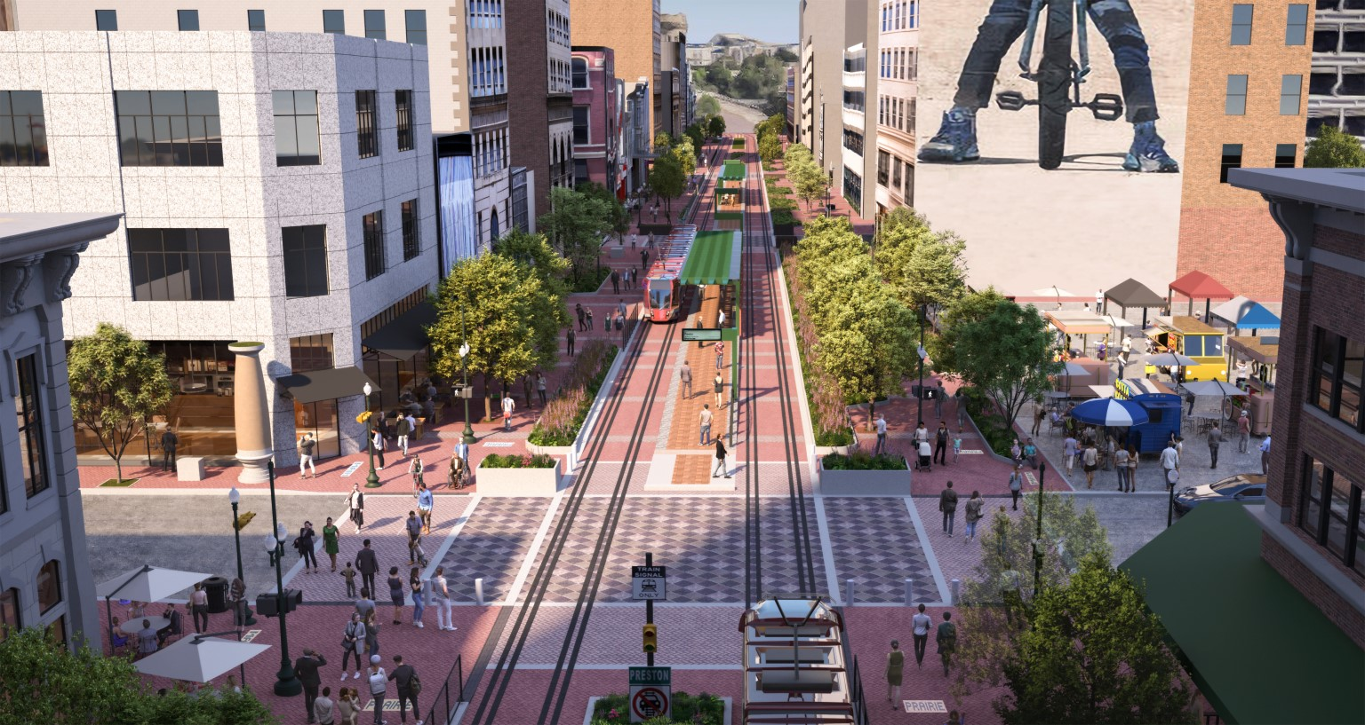
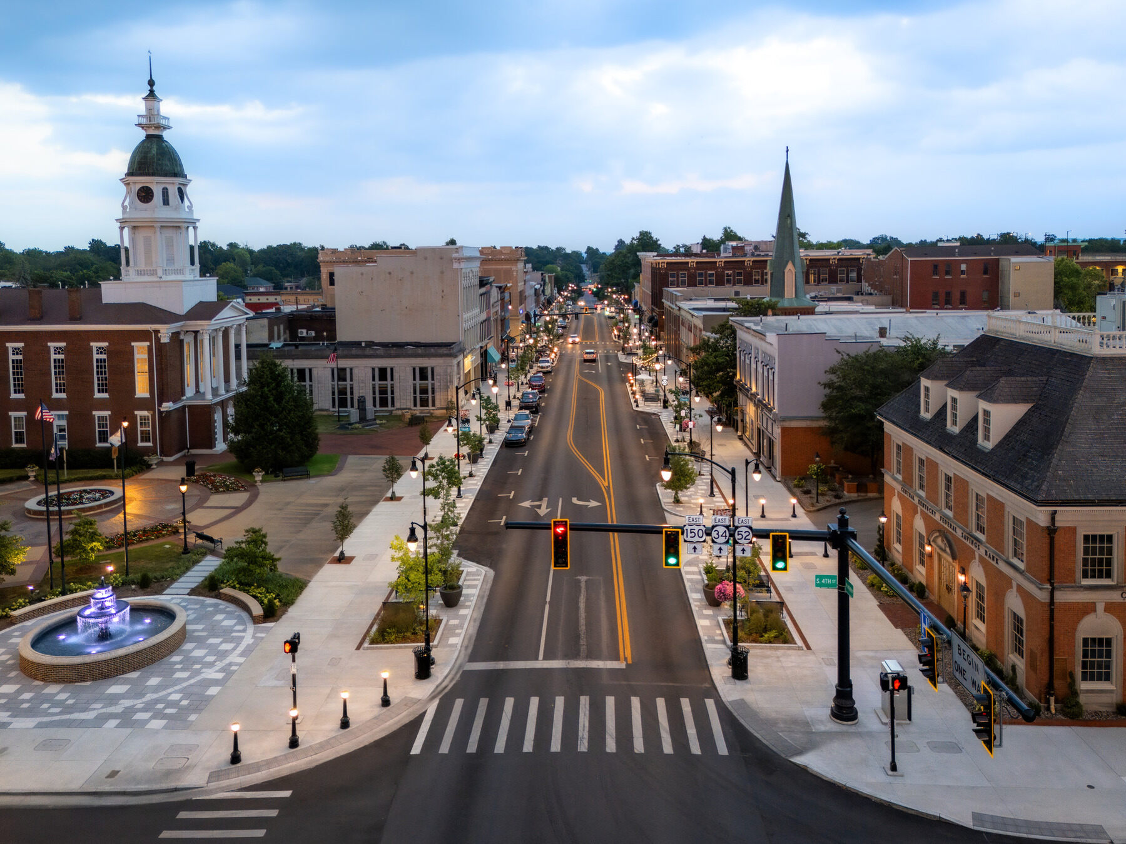
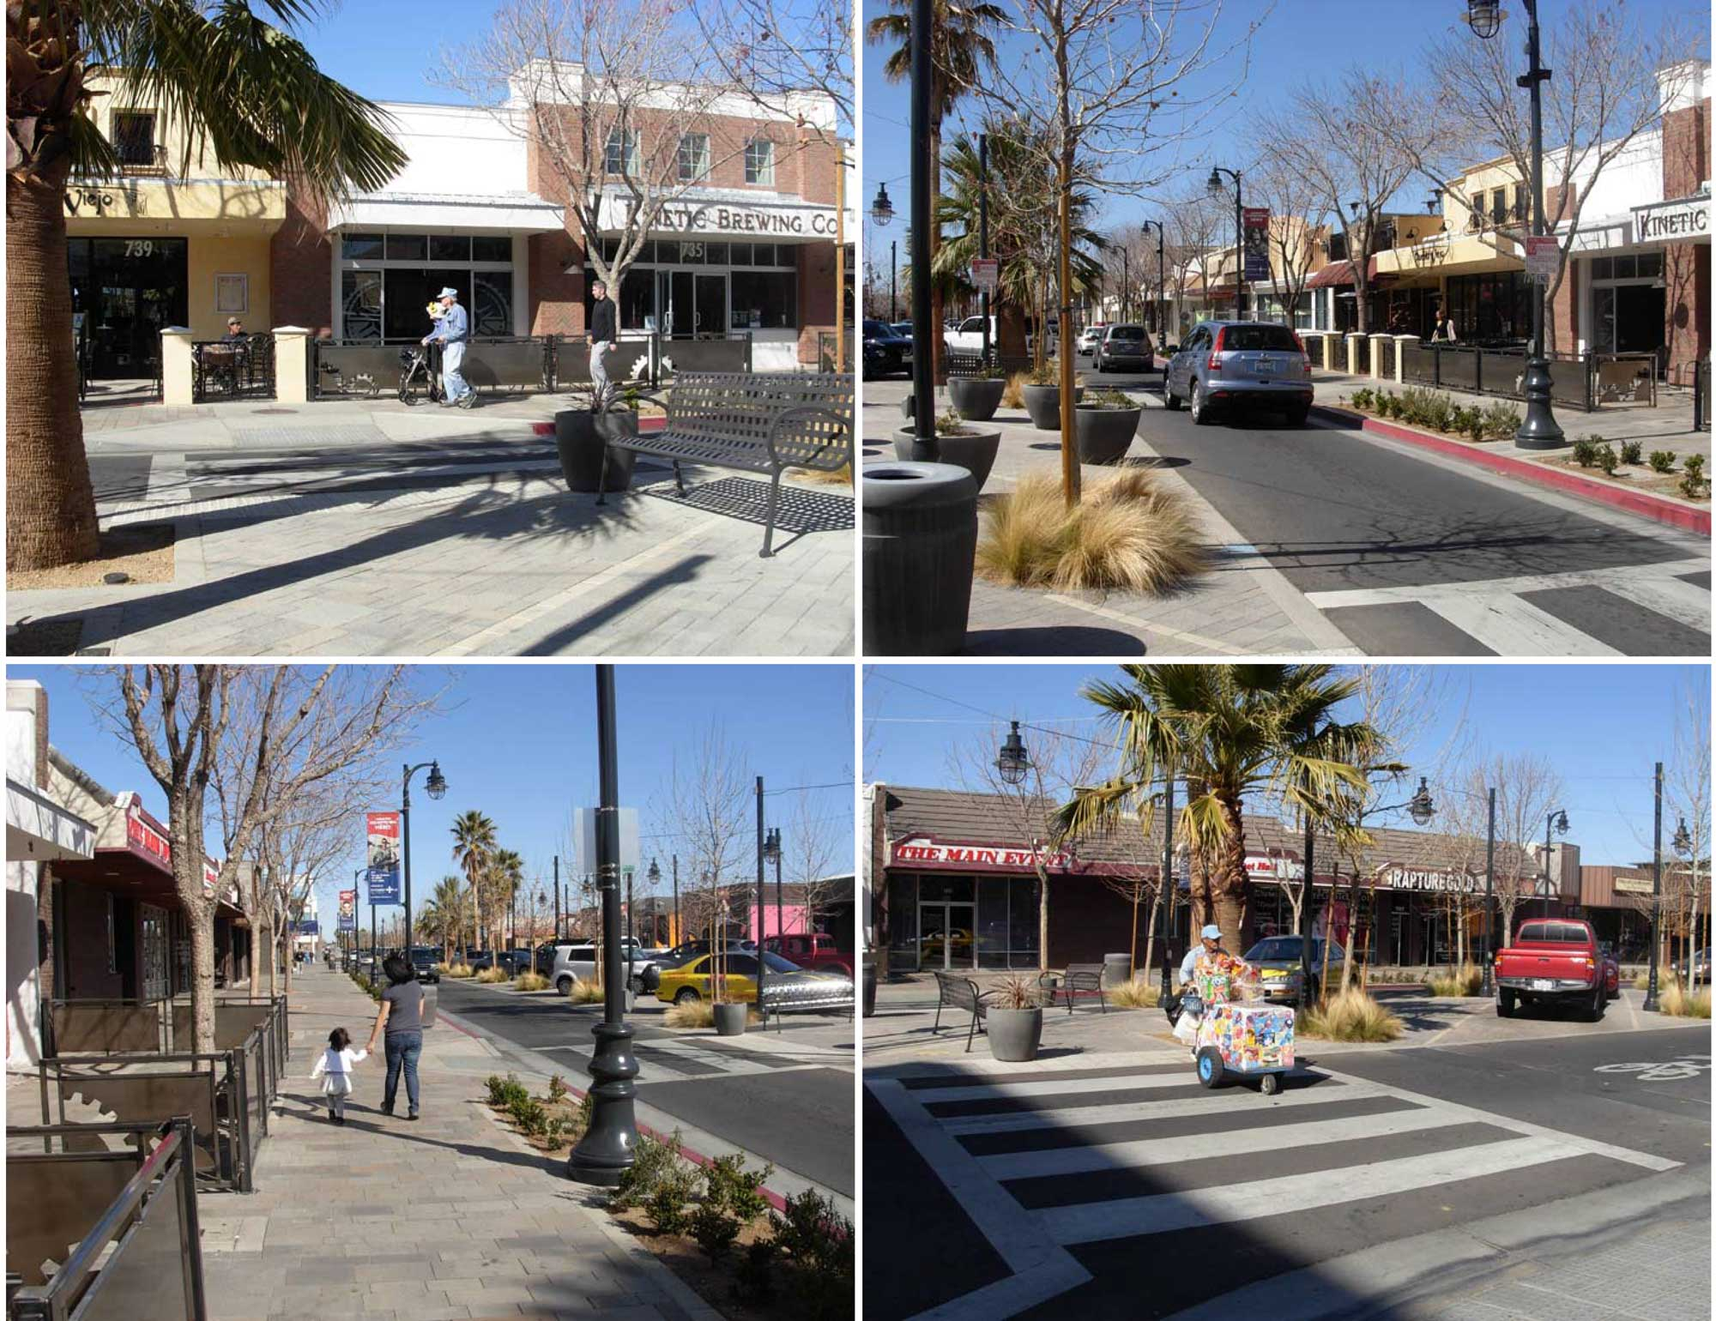

Older town centers often have challenges such as:

- Shallow lots and irregular parcels
- Buildings that predate zoning
- Nonconforming uses and structures
- Underutilized second floors
- Surface parking interruptions
- Unclear redevelopment expectations

Form-Based Codes are uniquely suited to these conditions because they work with the existing urban fabric rather than against it.

4.1 A Tool for Incremental Repair

FBCs enable:

- Infill on small and irregular lots
- Vertical additions where appropriate
- Reuse of historic buildings
- Mixed-use without constant special permits

They allow communities to repair the street wall, restore continuity, and gradually modernize building stock.

5. Form-Based Codes as an Upzoning Tool—Without the Fear

Upzoning is often politically fraught because it is perceived as:

- Unlimited density
- Loss of character
- Overwhelmed infrastructure

Form-Based Codes de-risk upzoning by tying additional density directly to physical outcomes the community can see and understand.

5.1 How FBCs Make Upzoning Palatable

Instead of saying:

“This district allows 4.0 FAR and 65 feet of height”

An FBC says:

“Buildings may be up to five stories, step back above the third floor, align with neighboring façades, activate the ground floor, and frame the street.”

This reframing:

- Makes scale legible
- Shows where height goes
- Protects light, air, and walkability
- Reinforces local character

Some FBCs incorporate a measure of conventional zoning criteria to clarify or expound on some provisions. Additionally, the more conventional features, the more a code may be considered “hybrid” rather than “pure” form-based.

6. Key Components of a Form-Based Code
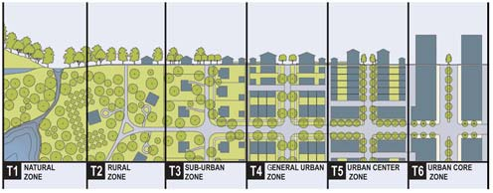

Subdistricts or “transects” distinguish areas with different development outcomes.
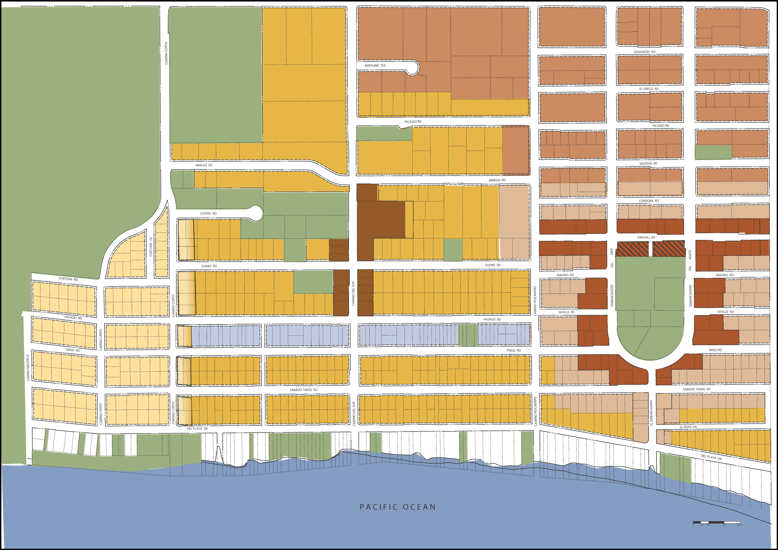

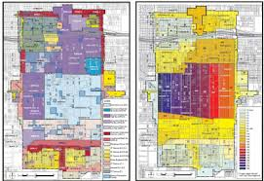

6.1 Regulating Plan

The regulating plan replaces the conventional zoning map. It assigns form districts based on desired character and intensity, not just use. The form districts or transects are shown on the Regulating Plan.

6.2 Building Envelope Standards

These define:

- Maximum and minimum heights
- Stepbacks
- Build-to zones
- Lot coverage

6.3 Frontage Standards

Frontages define how buildings meet the street:

- Shopfronts or Storefronts
- Stoops
- Forecourts
- Galleries

These are critical in revitalizing retail and mixed-use streets.

6.4 Public Realm Standards

Often coordinated with DPW and engineering:

- Sidewalk widths
- Street trees
- Curb zones
- Outdoor dining areas

6.5 Use Standards (Secondary)

Uses are typically:

- Broadly permissive
- Mixed-use friendly
- Focused on compatibility rather than separation

7. Economic Development Benefits

Form-Based Codes directly support economic revitalization by:

- Reducing entitlement risk
- Shortening permitting timelines
- Enabling phased investment
- Supporting small developers
- Encouraging local-serving retail

Predictability = Investment

When developers and property owners know:

- What can be built
- How tall it can be
- How it must relate to neighbors

They are more likely to invest, especially in incremental projects, which are the backbone of healthy town centers.

8. Housing Production and Diversity

Form-Based Codes naturally support:

- Upper-story housing
- Smaller units
- Workforce and senior housing
- Gentle density increases

By focusing on form rather than household type, FBCs allow housing to be added without changing the perceived scale of the street.

9. Design Quality Without Subjectivity

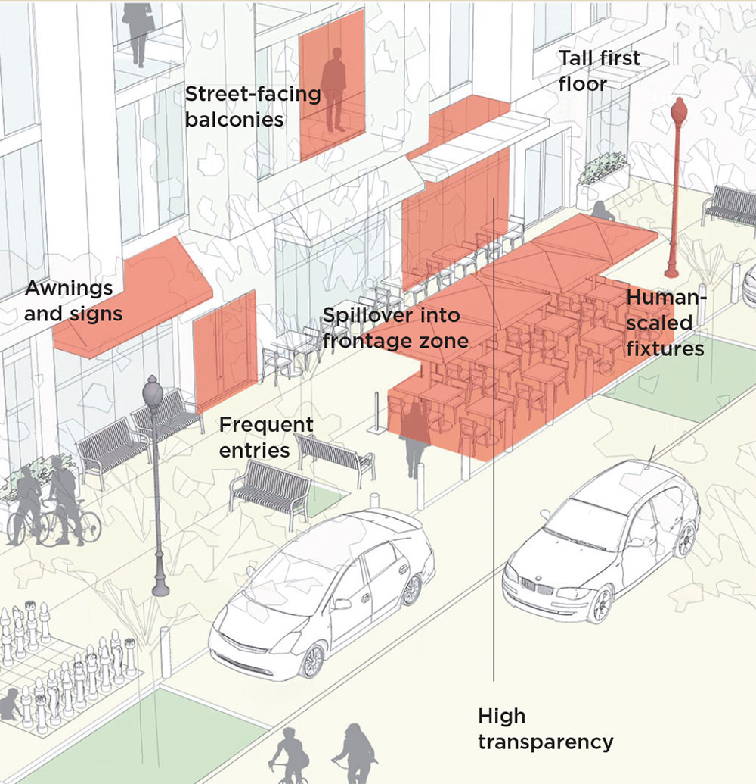
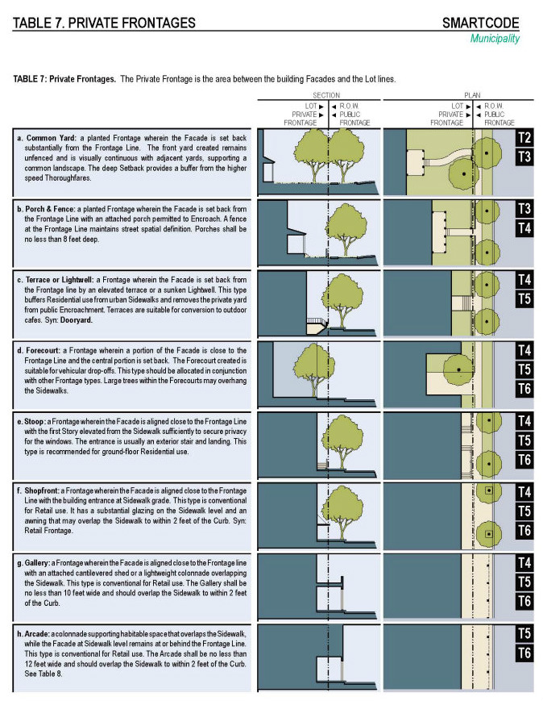

One of the greatest strengths of FBCs is that they:

- Replace subjective design review with clear rules
- Reduce political pressure on boards
- Improve consistency across projects

Illustrated standards allow applicants, neighbors, and decision-makers to see compliance, not debate taste.

10. Administration, Equity, and Long-Term Success

10.1 Administrative Efficiency

Well-crafted FBCs:

- Shift approvals to site plan review or administrative review
- Reduce variance requests and minimize special permits
- Free boards to focus on truly complex projects

10.2 Equity and Access

By lowering barriers to entry:

- Small property owners can reinvest
- Local developers can compete
- Housing types diversify naturally

11. Common Misconceptions

Myth | Reality
“FBCs force a single style” | They regulate form, not architecture
“They eliminate public input” | Input happens throughout development continuum
“They cause overdevelopment” | They tightly control scale and massing

12. Conclusion: A Tool for Renewal, Not Reinvention

Form-Based Codes are not about turning a town center into something it is not. They are about:

- Reinforcing what already works
- Fixing what is broken
- Providing a clear path forward

For older town centers that are economically underperforming but rich in character, Form-Based Codes offer a measured, understandable, and resilient framework—one that supports reinvestment, housing, and community life while maintaining trust and predictability. They are, fundamentally, a tool for stewardship: guiding change thoughtfully rather than reacting to it piecemeal.

References and Sources

Foundational Form-Based Code Literature

Duany, A., Plater-Zyberk, E., & Speck, J. (2000). Suburban Nation: The Rise of Sprawl and the Decline of the American Dream. New York, NY: North Point Press.
Duany, A., & Talen, E. (2002). Transect planning. Journal of the American Planning Association, 68(3), 245–266.
Parolek, D., Parolek, K., & Crawford, P. (2008). Form-Based Codes: A Guide for Planners, Urban Designers, Municipalities, and Developers. Hoboken, NJ: John Wiley & Sons.
Parolek, D. (2020). Missing Middle Housing: Thinking Big and Building Small to Respond to Today’s Housing Crisis. Washington, DC: Island Press.

Professional Guidance and Model Codes

Congress for the New Urbanism (CNU). (2014). Form-Based Codes: A Step-by-Step Guide for Communities. Chicago, IL: Congress for the New Urbanism.
Congress for the New Urbanism. (2023). Form-Based Codes Institute (FBCI) Resources and Best Practices. Retrieved from https://formbasedcodes.org
U.S. Environmental Protection Agency. (2013). Smart Growth Zoning Codes: A Guide. Washington, DC: U.S. EPA.

Economic Development, Predictability, and Entitlement Risk

Leinberger, C. B. (2007). The Option of Urbanism: Investing in a New American Dream. Washington, DC: Island Press.
Urban Land Institute. (2015). Building Healthy Places Toolkit. Washington, DC: ULI.
Urban Land Institute. (2018). Successful Infill Development. Washington, DC: ULI.

Town Centers, Main Streets, and Incremental Development

Jacobs, J. (1961). The Death and Life of Great American Cities. New York, NY: Random House.
Speck, J. (2018). Walkable City Rules: 101 Steps to Making Better Places. Washington, DC: Island Press.
National Main Street Center. (2020). Main Street Now: Revitalization Strategies for Traditional Commercial Districts. Washington, DC.

Design Standards, Public Realm, and Walkability

Gehl, J. (2010). Cities for People. Washington, DC: Island Press.
Whyte, W. H. (1980). The Social Life of Small Urban Spaces. Washington, DC: Conservation Foundation.
NACTO. (2013). Urban Street Design Guide. New York, NY: National Association of City Transportation Officials.

Housing Diversity and Gentle Density

Missing Middle Housing Initiative. (2019). Housing Types and Form-Based Zoning. Retrieved from https://missingmiddlehousing.com
Metropolitan Area Planning Council (MAPC). (2021). Housing Production Plan Best Practices. Boston, MA.

Implementation, Governance, and Administration

American Planning Association. (2020). PAS Report No. 619: Zoning Reform for the 21st Century. Chicago, IL: APA.
Meck, S., Retzlaff, R., & Schwab, J. (2006). Zoning Practice: Form-Based Codes. Chicago, IL: American Planning Association.

Massachusetts / New England Context

Metropolitan Area Planning Council (MAPC). (2018). Perfect Fit Parking and Zoning Reform Studies. Boston, MA.
Massachusetts Office of Energy and Environmental Affairs. (2021). Smart Growth / Chapter 40R and 40S Guidance. Boston, MA.

FB is short for “Form Based”, which is in reference to the form-based zoning code the BCOD & CGOD. See Appendix B for more information on form-based codes.
Zoning is a system of local laws and regulations used by municipalities to divide land into different "zones" or "districts." Each zone is designated for certain types of uses—like residential, commercial, industrial, or agricultural—and may also set specific rules about building heights, density, setbacks, and how properties can be developed or used. Zoning determines what can be built and where in a given community to ensure an orderly, functional, and harmonious pattern of development. Changes to zoning would give more options to the building owners in the center, to enhance their properties, should they choose to.
A density bonus in zoning is a tool used to incentivize developers to provide public benefits, by allowing them to build at a higher density than normally permitted in a given area. Essentially, developers get permission to build larger structures than usual in exchange for incorporating features that benefit the community. Note that density bonuses are reviewed and approved by the Planning Board, not automatically granted.

